SPRINT 1

|  |  |
| --- | --- |
| Date | 19th NOVEMBER 2022 |
| Team ID | PNT2022TMID277860 |
| Project Name | Project – Signs with Smart Connectivity for Better Road Safety |

**Wokwi Simulation**: Rajeshfinal https://wokwi.com/projects/348855035785904723

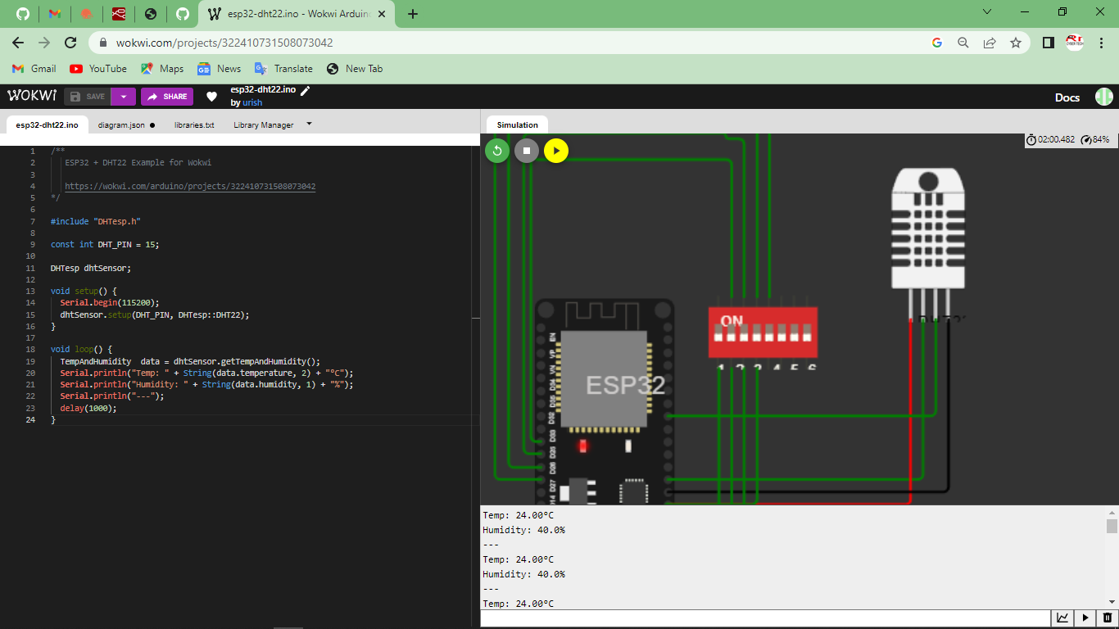

IoT Device – IoT Platform

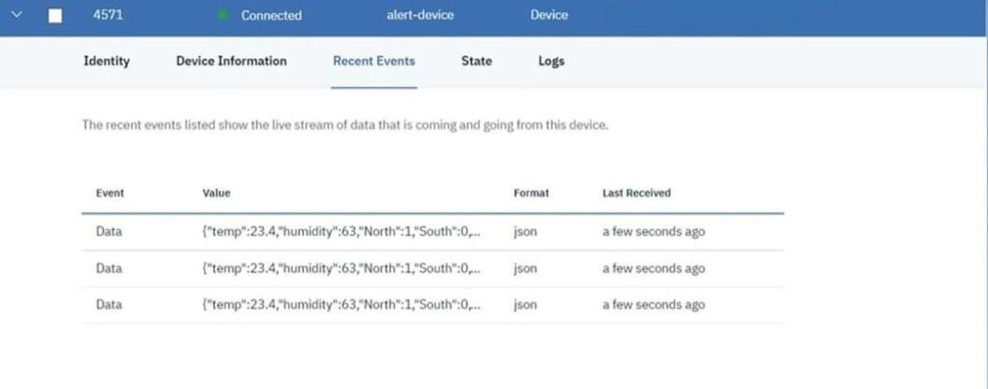

Node Red

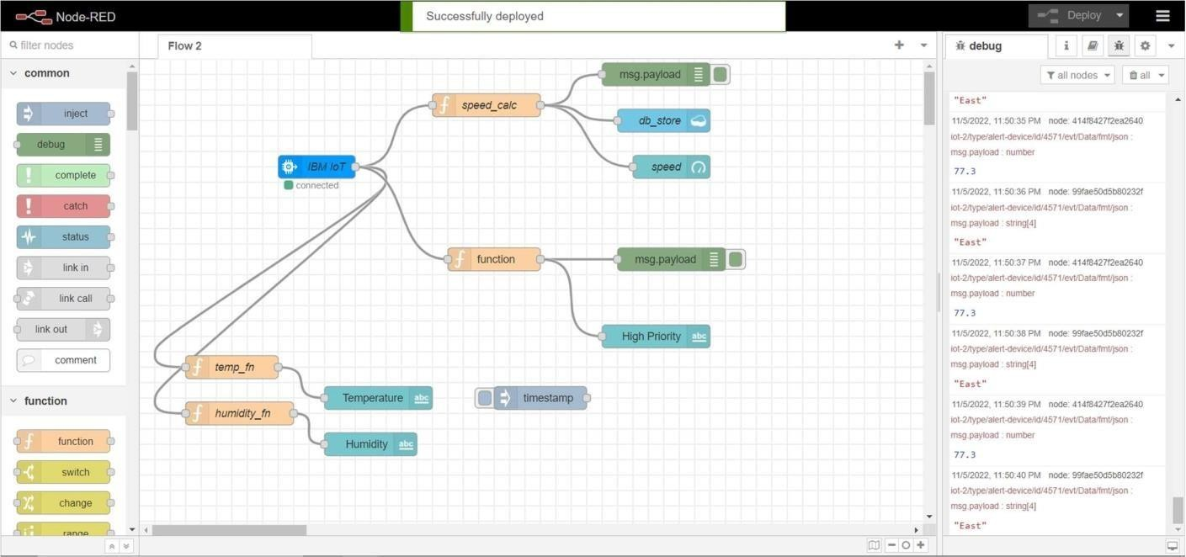

Node Red Web UI

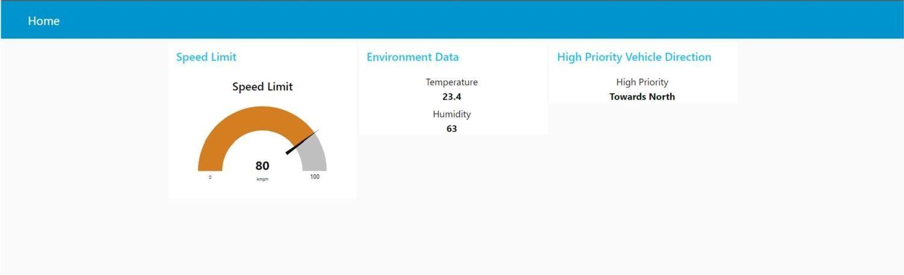

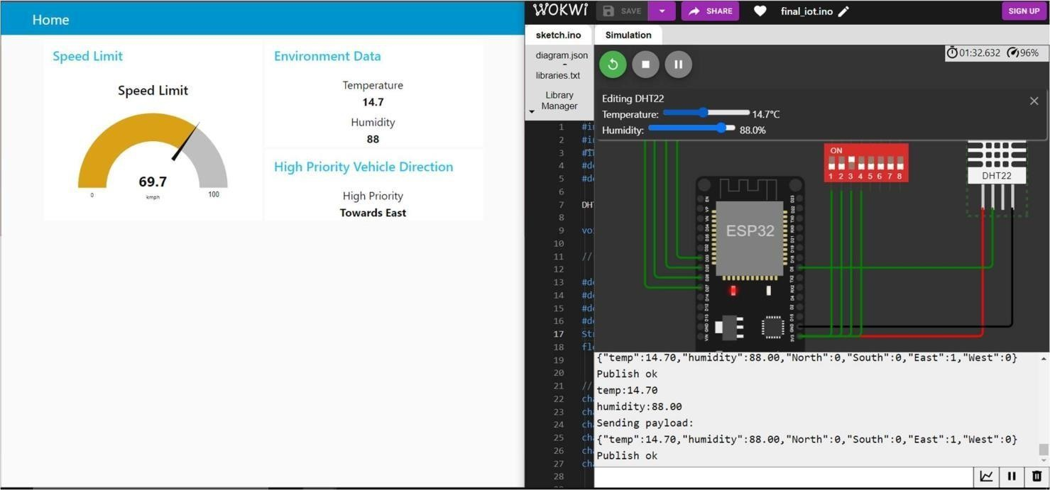

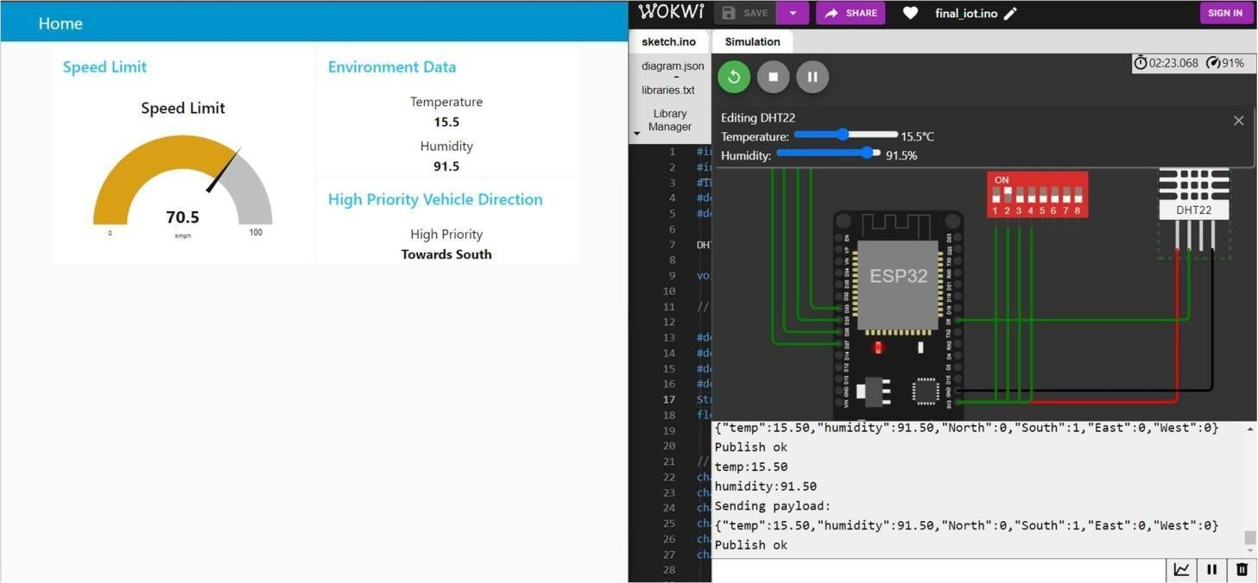

Cloudant Database

